Honorary Secretary
Geoff Davis
secretary.dcjb@branches.imarest.org

Honorary Treasurer
Liz Tier

Annual General Meeting 2022

Reducing Fossil-fuelled Engine Emissions

Mr Jason Munro, Ecomotus
Mr Adrian Bartlett, AB Marine Consultancy

Date: Thursday 20 September 2022

Time: 7 pm - 8:30pm

Venue: MLA College, The Merchant, St Andrew Street, Plymouth, PL1 2AX

Organiser: Devon & Cornwall Joint Branch

Contact: Secretary.dcjb@branches.imarest.org

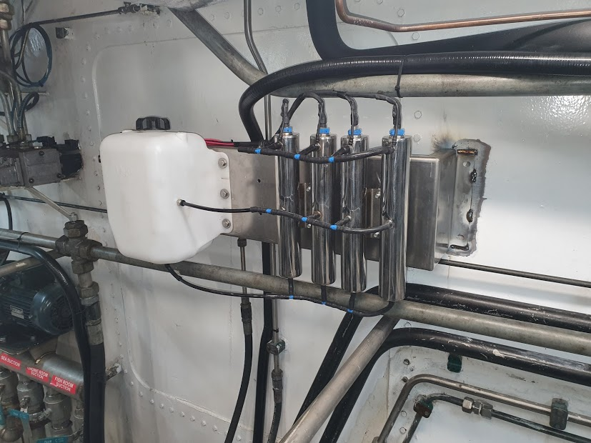
Meeting the IMO requirements for carbon reduction will be particularly challenging for companies with current fossil-fuelled ships planned for service beyond 2050. The EcoPro manufactured by Ecomotus is an innovative catalytic hydrogen system designed to reduce emissions and work in harmony with existing internal combustion engines of all sizes and applications.

This presentation will illustrate the potential benefits of adding hydrogen to the air-fuel mixture

Mr Jason Munro is a director of Ecomotus, Mr Adrian Bartlett is a director of AB Marine Consultancy working in association with Ecomotus.
You are invited to attend the AGM and talk at MLA College. The meeting will also be transmitted online.
For further information, please contact secretary.dcjb@branches.imarest.org.

CPD Attendance Name …………………………………………… Committee member signature …………………………………

