Aberdeen Maritime Joint Branch

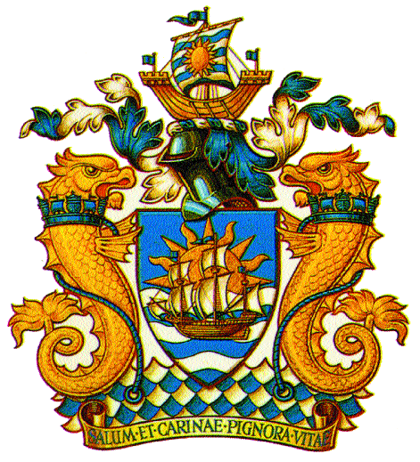
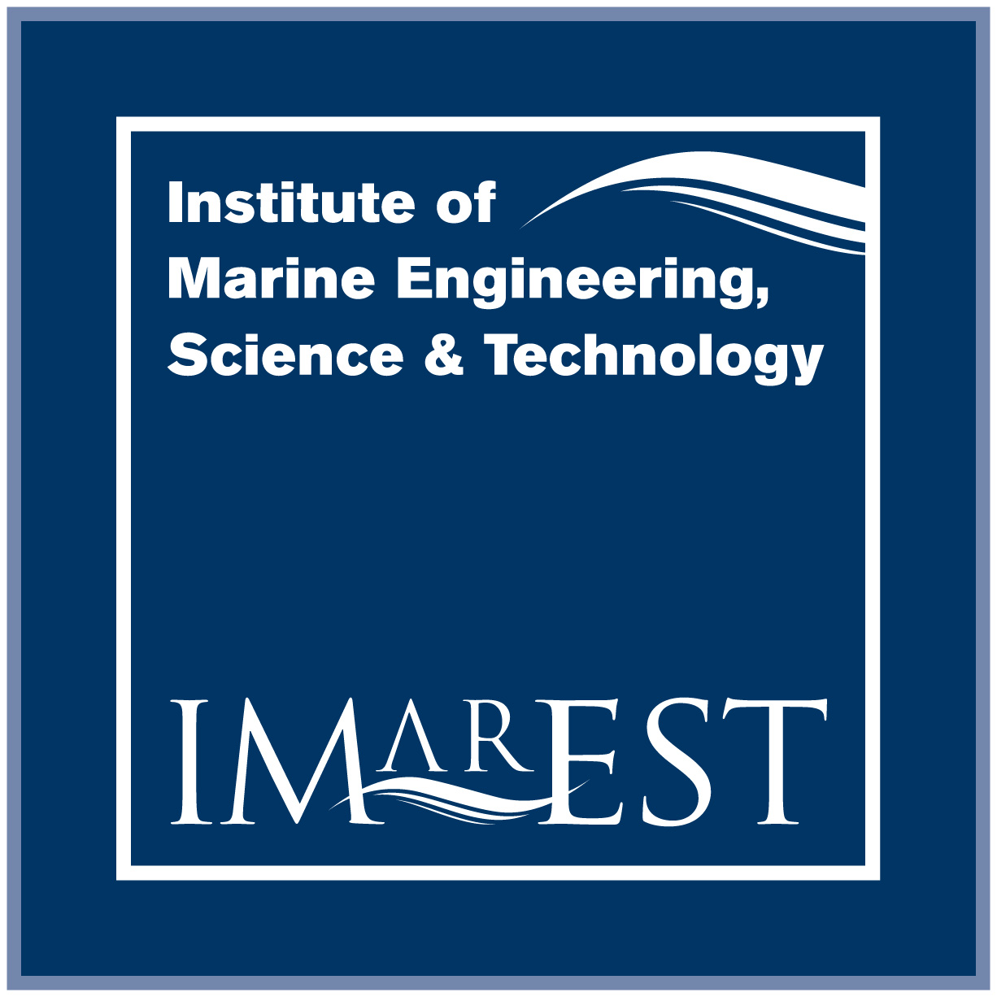
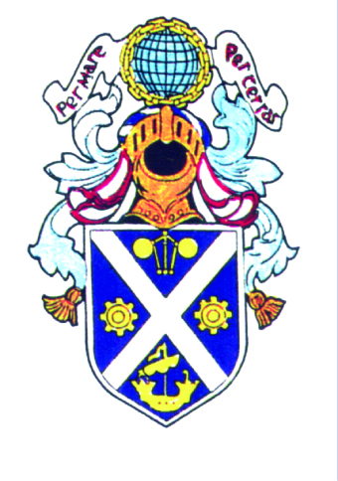
A Joint Branch of the RINA and the IMarEST and the IESIS

Branch Chairman:
Mr. Bryan Bain, MIMarEST
bbain@morconenergy.com

Hon. Secretary:
Mr. William Paterson, IEng, IMarEng, MIMarEST
patersonw@googlemail.com

Hon. Treasurer: The Royal Institution of Naval Architects
Eur.Eng David Armstrong, CEng, CMarEng, FIMarEST The Institute of Marine Engineering Science and Technology
david.armstrong@lr.org The Institution of Engineers and Shipbuilders in Scotland

Technical Presentation

Date: Wednesday 24th February 2016
Time: 18.30 hrs (Tea / Coffee / Sandwiches requested for 18.00 hrs)
Venue: RGU Garthdee, Aberdeen – Faculty of Health & Social Care (FHSC) – Room H230
Parking: Parking available on site.

“Friction Welding in Offshore Floating Production Systems”

Presented by

Stuart Harvey of Proserv

Non Members Welcome!

ARE YOU WILLING OR DO YOU HAVE AN INTERESTING TECHNICAL TOPIC TO PRESENT? IF SO PLEASE CONTACT A COMMITTEE MEMBER

