Aberdeen Maritime Joint Branch

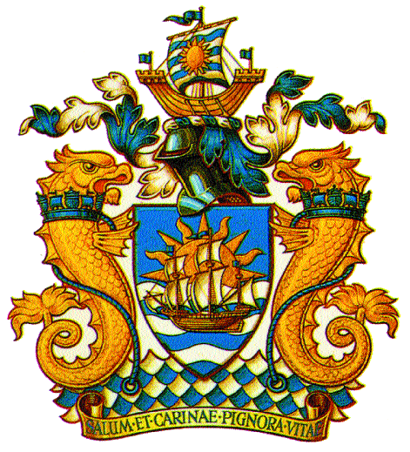
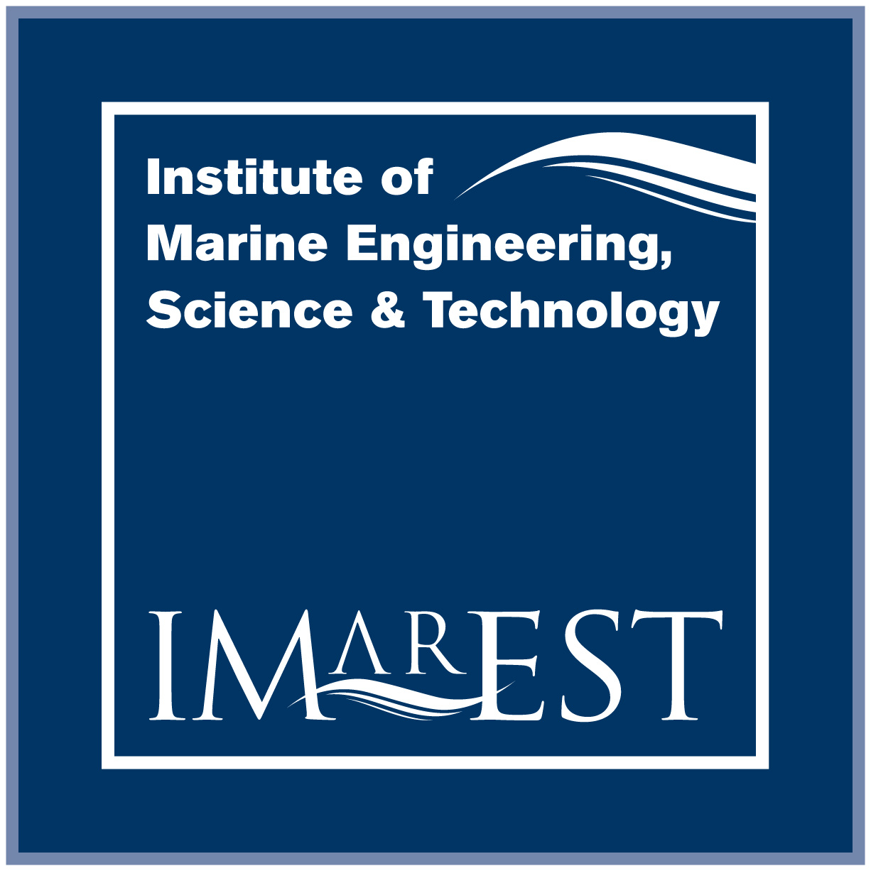
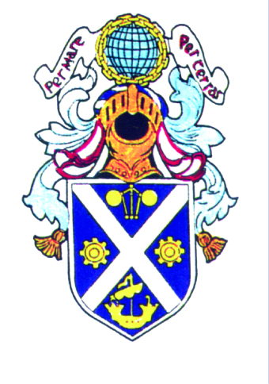
A Joint Branch of the RINA and the IMarEST and the IESIS

Branch Chairman:
Mr. Bryan Bain, MIMarEST
bbain@morconenergy.com

Hon. Secretary:
Mr. William Paterson, IEng, IMarEng, MIMarEST
patersonw@googlemail.com

Hon. Treasurer: The Royal Institution of Naval Architects
Eur.Eng David Armstrong, CEng, CMarEng, FIMarEST The Institute of Marine Engineering Science and Technology
david.armstrong@lr.org The Institution of Engineers and Shipbuilders in Scotland

Technical Presentation

Date: Wednesday 30th March 2016
Time: 18.30 hrs (Tea / Coffee / Sandwiches requested for 18.00 hrs)
Venue: RGU Garthdee, Aberdeen – Faculty of Health & Social Care (FHSC) – Room H230
Parking: Parking available on site.

Dynamic Positioning – “Busy Going Nowhere”

Presented by

Dr Stephen Cargill of Noble Denton Marine Services

Dynamic positioning is the preferred method of carrying out a wide variety of marine operations and is, in some cases, the only option. The safety critical nature of many DP activities demands high station keeping integrity. Much has been learned about how to build and test fully fault tolerant control, power and propulsion systems in the last ten years and the latest designs are considerably tougher and more robust than their predecessors. This presentation discusses the engineering developments that drove these improvements and the advanced verification processes that accompany them.

ARE YOU WILLING OR DO YOU HAVE AN INTERESTING TECHNICAL TOPIC TO PRESENT? IF SO PLEASE CONTACT A COMMITTEE MEMBER

