14th Symposium on
High-Performance Marine Vehicles – “Technologies for the Ship of the Future”

Cortona / Italy, 29-31 August 2022

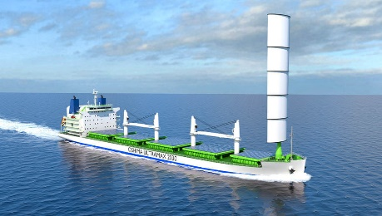 |  | 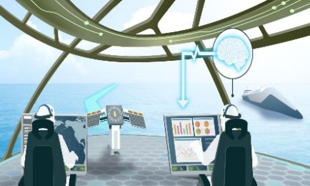

Topics: ultra-efficient & zero-emission ships / EEXI & CII issues / alternative fuels / electric ships
advanced designs / shipyard 4.0 / future materials / future use of oceans / blue economy /
intelligent & connected ships / future antifouling / biomimetic marine technologies
Organiser: Volker Bertram (volker@vb-conferences.com)
Advisory Committee:
Carlo Bertorello  Carsten Bullemer  Emilio Campana  Roy Campe  Andrea Coraddu | Naples University  Maritime Data Systems  CNR  CMB  TU Delft | Robert Dane  Stefan Harries  Thomas Hildebrandt  Jan Kelling  Jiulun Liu | Ocius  Friendship Systems  Numeca  Hasytec  Wuhan Univ Technology | Kohei Matsuo  Geir Axel Oftedahl  Pierre Sames  Noah Silberschmidt  Teus van Beek | NMRI  Semcon  DNV  Silverstream Technologies  Wärtsilä

Venue: The conference will be held at the “Oasi Neumann Hotel” in Cortona/Italy
Format: Papers to the above topics are invited and will be selected by a selection committee.
Proceedings will be electronic pdf version in colour.

Deadlines: anytime Optional “early warning” of interest to submit paper
18.5.2022 First round of abstract selection (1/3 of available slots)
18.6.2022 Second round of abstract selection (remaining 2/3 of slots)
1.8.2022 Final papers due (50 € surcharge for late submission)
Fees: 650 € / 350 € regular / PhD student – early registration (by 1.8.2022)
750 € / 400 € regular / PhD student – late registration
Fees are subject to VAT
Fees include proceedings, lunches and coffee breaks, and conference dinner
Fees apply also to authors
Sponsors: Tutech Innovation, Ecap Marine, Hasytec – further to be announced

Media Partner: Hansa

Information: volker@vb-conferences.com or volker.bertram@dnv.com

Sneak preview of planned papers (only first author displayed)

Anriette Bekker (Stellenbosch University) - Mariner 4.0 Digital Twin
Volker Bertram (DNV) – Towards a biocide-free antifouling future exploring lesser travelled paths
Ulrich Bernhardt (DNV) – Effective Digital Training Solutions to Support the Maritime Digital and Decarbonization Transitions
David Connolly (Silverstream Technology) – Proving Energy Savings in Air Lubrication Technology
Robert Dane (Ocius) – Cooperation Makes it Happen: Autonomous Drones with Sustainable Propulsion
Colm Dudley (Warwick University) - WarwickSub: Human-Powered Submarine Project as Test Platform for Advanced Technologies
Jonathan Evans (StrucTEAM) - Sustainability developments for composite materials in maritime applications
Ramesh Babu Govinderaj (DNV) – Additive Manufacturing for Maritime Applications
Tim Heusinger von Waldegge (Fraunhofer) - Underwater hull cleaning by laser: Feasibility and prospects
Thomas Hildebrandt (Numeca) – Using Machine Learning for Rapid Propeller Design Tools based on Numerical Series
Thomas Hipke (Fraunhofer IWU) - Metal Foams in Shipbuilding
Morten Løvstad (DNV) - The Decarbonizing Quest for Future Bulk Carriers
James Mason (Univ Manchester) - Stochastic Uncertainty in Fuel-Optimised Ship Routing: How Weather Forecasts Hinder the Carbon Savings from Wind-Assisted Weather Routing
Ruben J. Paredes (ESPOL) - Optimal conceptual design of a zero-emission interisland service craft
Lars Ravens (Ecap Marine) – Clean Power Solutions for the Maritime World
Jonas W. Ringsberg (Chalmers TU) - Analysis of uncertainties in the prediction of fuel saving from WASP installations
Benjamin Scholz (DNV) - Recent Developments in Maritime Fuel Cell Technology Projects
Fabian Thies (Chalmers TU) - Hull form optimization for wind-powered and wind-assisted ships
David Thomson (AVEVA) - The Maritime Galaxy of the up-and-coming Metaverse
Vincent Schneider (Fraunhofer CML) - The development of a battery hot swap prototype for use on the Autonomous Surface Vehicle SeaLion
Svend Soyland (Nordic Energy) – First Experience with Hydrogen and Ammonia as Shipping Fuels
Syb ten Cate Hoedemaker (Maritime Battery Forum) – Overview of Current Status of Maritime Batteries

