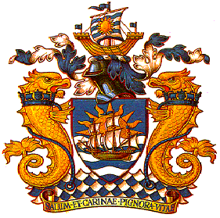

RINA LONDON BRANCH
ANNUAL GENERAL MEETING
Tuesday, 15th April 2014

1. Minutes of the Previous AGM

The Minutes of the previous Annual General Meeting (25th April 2013) were accepted as submitted.

2. Annual Report of the Branch Council

The Honorary Secretary, Lourdes Lilley, presented the Annual Report of the Branch Council.
The meeting approved the Annual Report.

3. Financial Report

In the absence of the Honorary Treasurer, the President presented the Branch Financial Report.
The meeting approved the Financial Report.

4. Council Status and Membership for the Season 2014/2015

The Council put forward the following list of Officers for election en block for the new season 2014/2015.

Officers:

Keith Lilley President
Jonathan Morley Vice President
Peter Jenkins Vice President
Leo Andrelos Honorary Treasurer
Lourdes Lilley Honorary Secretary
Victor Crockett Technical Secretary
Jair Ferreira Marketing Secretary
Imtaz Khan Communication Secretary
Luke Versey YMG Chairman

Acceptance proposed by: Ian Meaden
Acceptance seconded by: Lourdes Lilley

The Officers were duly elected.

Members:

The meeting were informed that the following Council members were to continue their terms as members of the Council as per the constitution.

Roy Thompson
Serdar Isik
Sabahat Malik
Tim Russell
Zafer Ayaz

Resignations from the Council:

The meeting was informed that there were three resignations from the Council:

Heike Deggim
Aureliano Schirripa
Elizabeth McCaig

All three were thanked for their valued contribution to Branch duties during their time on the Council.

Members seeking Election:

The meeting was informed that four nominations for election to the Council had been received, namely

Ian Meaden
Periklis Chaigker
Yash Modi
Song Wang

The meeting was informed that all candidates were proposed as members of the Council and their election requested.

Acceptance proposed by: Tim Russell
Acceptance seconded by: Victor Crockett

The Chairman welcomed the duly elected new members to the RINA London Branch Council.

5. Any Other Business

There were no issues raised under “Any other business”

Thanking the Council for their support and the members for their attendance throughout the year, the Chairman declared the 2014 RINA London Branch AGM closed.

