Aberdeen Maritime Joint Branch

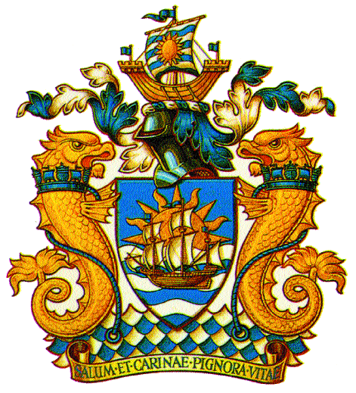
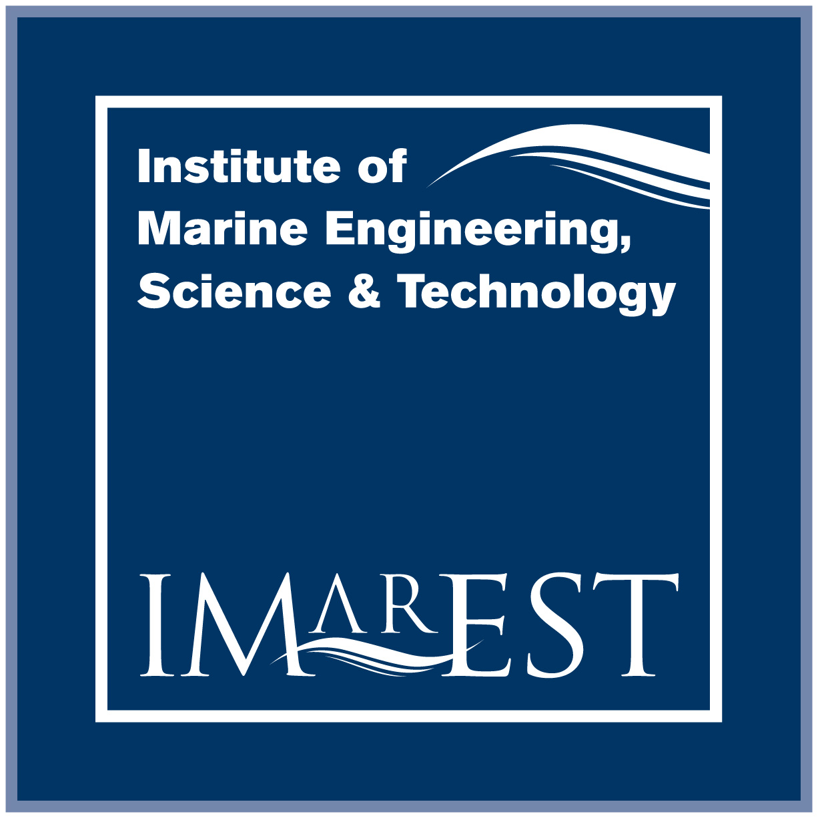
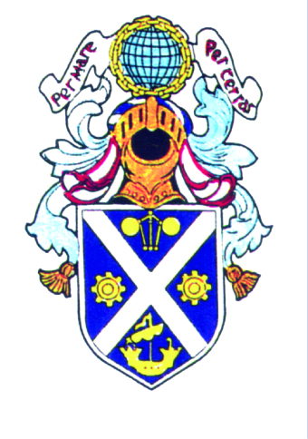
A Joint Branch of the RINA and the IMarEST and the IESIS

Branch Chairman:
Mr. Harry Knox, IEng, IMarEng, MIMarEST

Hon. Secretary:
Mr. William Paterson, IEng, IMarEng, MIMarEST

Hon. Treasurer: The Royal Institution of Naval Architects
Eur.Eng David Armstrong, CEng, CMarEng, FIMarEST The Institute of Marine Engineering Science and Technology
The Institution of Engineers and Shipbuilders in Scotland

Technical Outing

Donside Micro Hydro-Electric Scheme
Aberdeen Community Energy

Family visit and aspiring young engineers
Date : Saturday 23rd September 2017
Time : 14:00 hrs / 15:00 hrs / 16:00 hrs
Registration : https://www.eventbrite.co.uk/e/donside-micro-hydro-electric-scheme-technical-outing-families-tickets-37121553566

Members
Date : Thursday 28th September 2017
Time : 18:00 hrs
Registration : https://www.eventbrite.co.uk/e/donside-micro-hydro-electric-scheme-technical-outing-members-tickets-37120536524

Numbers are limited to 25 persons per session so it will be first come first served.
Please register through the eventbrite invite
Visit expected to take about 1.0 hour,
Location: Nearest post code is AB24 2PB,
Parking available nearby (along Papermill Avenue) and assembly by the Generator House (Please note the site is not in Google Maps)

For more information, Contact:
Mr. Mark Bragg, MIMarEST, STEMNET Director, Donside Hydro (mark.bragg.ceng@gmail.com)

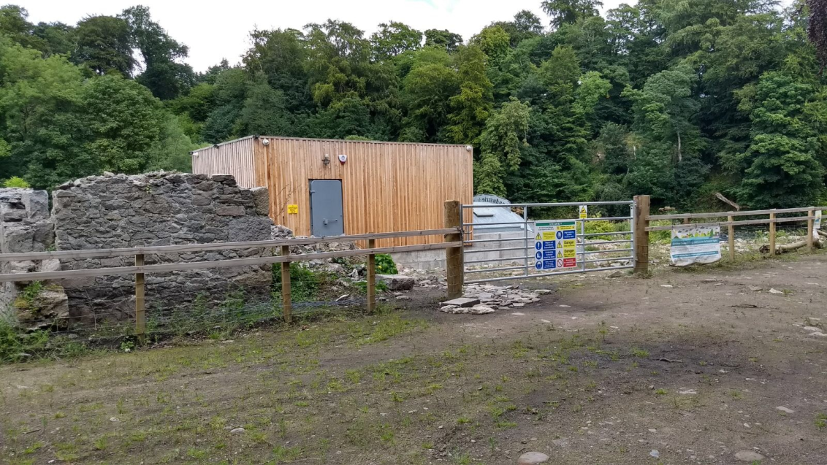
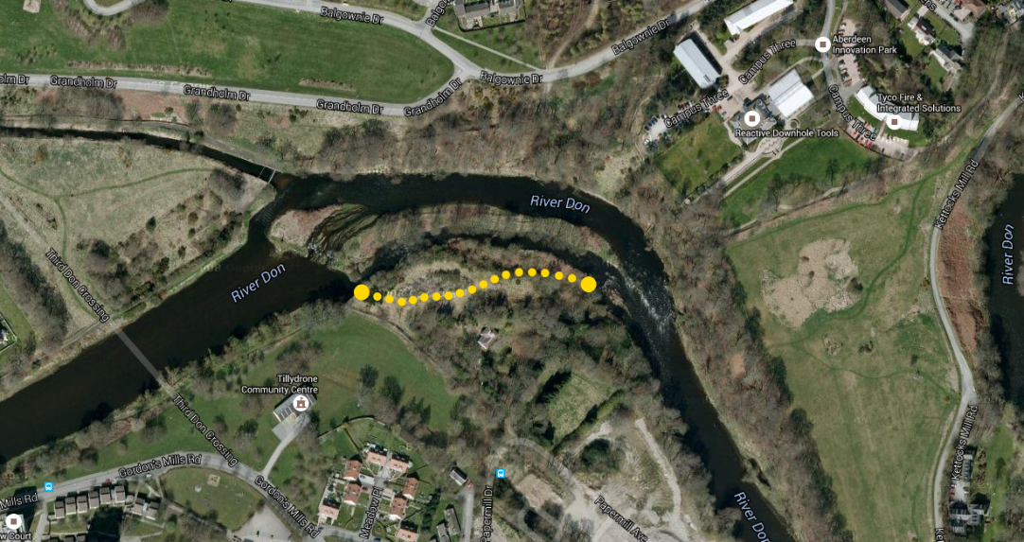
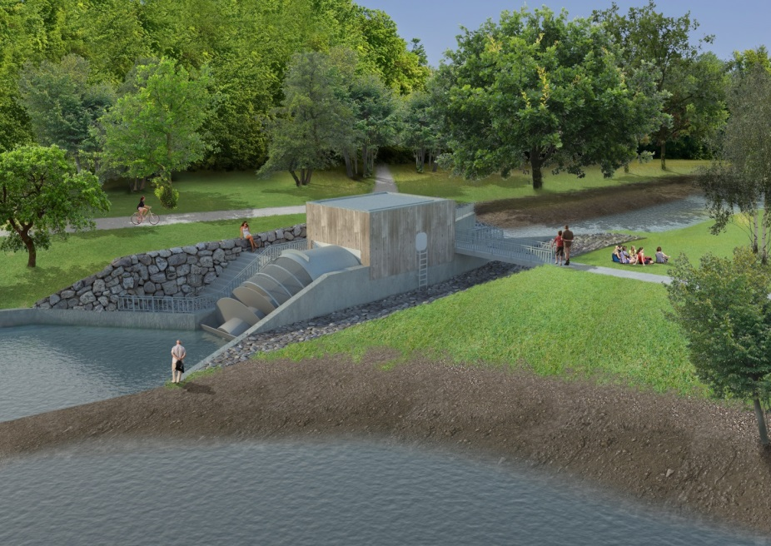
Please bring sturdy outdoor footwear and weatherproof high visibility jacket is recommended as the site may be muddy.
Generator House
(Assembly Point)

